**Assignment 1: Excel MCQs**

**Section A: 2 Marks Each (Total 20 Marks)**

1. What function is used to sum a range of cells in Excel?

a) AVG

b) MAX

c) SUM

d) MIN

2. Which symbol is used to denote absolute cell reference in Excel formulas?

a) $

b) %

c) @

d) &

3. Which Excel feature allows you to visually represent data using charts and graphs?

a) PivotTables

b) Conditional Formatting

c) Sparklines

d) Data Validation

4. What does the function COUNTA() do in Excel?

a) Counts the number of cells in a range that are not empty

b) Counts the number of cells in a range that contain numeric values

c) Counts the number of cells in a range that contain text

d) Counts the number of cells in a range that meet a specific condition

5. Which of the following is not a valid Excel data type?

a) Number

b) Text

c) Date/Time

d) Image

6. What is the keyboard shortcut to open the "Format Cells" dialog box in Excel?

a) Ctrl + F

b) Alt + F4

c) Ctrl + 1

d) Shift + F10

7. Which function is used to find the largest value in a range in Excel?

a) MAX

b) MIN

c) LARGE

d) MAXIMUM

8. Which Excel feature is used to automate frequently performed tasks by recording a series of actions?

a) Solver

b) Scenario Manager

c) Macro Recorder

d) Goal Seek

9. Which function is used to combine text strings from different cells into one cell in Excel?

a) JOIN

b) CONCATENATE

c) MERGE

d) COMBINE

10. What does the function VLOOKUP() do in Excel?

a) Searches for a value in the first column of a table array and returns a value in the same row from a specified column

b) Searches for a value in a column and returns a value from the same row in a different column

c) Searches for a value in a column and returns a value from the same row

d) Searches for a value in a row and returns a value from the same column in a different row

**Section B: 3 Marks Each (Total 30 Marks)**

1. Which Excel function is used to count the number of cells within a range that meet a single condition?

a) COUNT

b) COUNTIF

c) SUMIF

d) AVERAGEIF

2. What does the function IFERROR() do in Excel?

a) Returns a specified value if a formula evaluates to an error; otherwise, returns the result of the formula

b) Returns the error value of a formula

c) Returns TRUE if a formula evaluates to an error; otherwise, returns FALSE

d) Returns the type of error generated by a formula

3. Which Excel feature is used to filter data based on specific criteria?

a) Sort

b) AutoFilter

c) Filter

d) PivotTable

4. What does the function SUBTOTAL() do in Excel?

a) Returns the total of the numbers in a range

b) Returns the subtotal for a vertical range of cells using a specified function

c) Returns the subtotal for a horizontal range of cells using a specified function

d) Returns the subtotal for a range of cells using a specified function, excluding hidden rows and columns

5. Which Excel feature is used to find the highest or lowest value in a range, and what option allows you to find the second highest or lowest value?

a) Conditional Formatting; Top/Bottom Rules

b) Goal Seek; Solver

c) Data Validation; Sparklines

d) Scenario Manager; What-If Analysis

#### 6. The charts below are based on the data in cells A3:G5. The chart on the right was created by copying the one on the left. Which ribbon button was clicked to change the layout of the chart on the right?

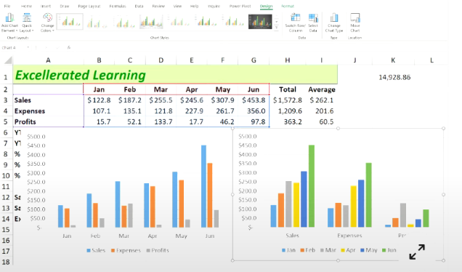

* a) Move Chart
* b) Switch Row/Column
* c) Quick Layout
* d) Change Chart Type

#### Q7. Which function, when entered into cell F2 and then dragged to cell F6, returns the performance rating text (e.g., "Good", "Poor") for each representative?

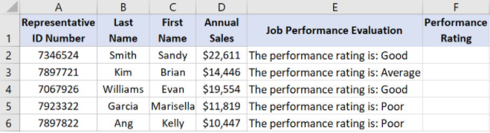

* a) =RIGHT(E2,LEN(E2)-27)
* b) =LEN(E2,MID(E2)-27)
* c) =LEFT(E2,LEN(E2)-27)
* d) =RIGHT(E2,MID(E2)-27)

#### Q8. Which is a valid Excel formula?

* a) =(A5+B5)*B7
* b) =A3-7(B3:B5+4)
* c) =(A5+B5)B7
* d) =B3^[2*/3]

Q.9 Hyperlinks Can Be In:

1. Drawing Objects
2. Text
3. Pictures
4. All of Above

#### Q10. The AutoSum formulas in the range C9:F9 below return unexpected values. Why is this?

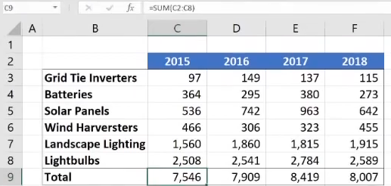

1. The AutoSum formulas refer to the column to the left of their cells.
2. The AutoSum formulas exclude the bottom row of data.
3. The AutoSum formulas include the year at the top of each column in the calculation. The formula bar clearly shows it's the dates (top row) included, along with the total (bottom) row. Thus, the bottom row of data is not excluded.
4. The AutoSum formulas include their own cells, creating a circular reference.

**SOLUTION**

Section 1: 10 Questions (2 marks each)

1. c) SUM
2. a) $
3. c) Sparklines
4. a) Counts the number of cells in a range that are not empty
5. d) Image
6. c) Ctrl + 1
7. a) MAX
8. c) Macro Recorder
9. b) CONCATENATE
10. a) Searches for a value in the first column of a table array and returns a value in the same row from a specified column

Section B: 3 Marks Each (Total 15 Marks)

1. b) COUNTIF

2. a) Returns a specified value if a formula evaluates to an error; otherwise, returns the result of the formula

3. c) Filter

4. d) Returns the subtotal for a range of cells using a specified function, excluding hidden rows and columns

5. a) Conditional Formatting; Top/Bottom Rules

6. d) Change Chart Type

7. a) =RIGHT(E2,LEN(E2)-27)

8. a) =(A5+B5)*B7

9. d) All of the above

10. c) The AutoSum formulas include the year at the top of each column in the calculation. The formula bar clearly shows it's the dates (top row) included, along with the total (bottom) row. Thus, the bottom row of data is not excluded